**INTRODUCTION TO VERSION CONTROL EXERCISE**

**QUES1-** Git Setup.

**Solution-**



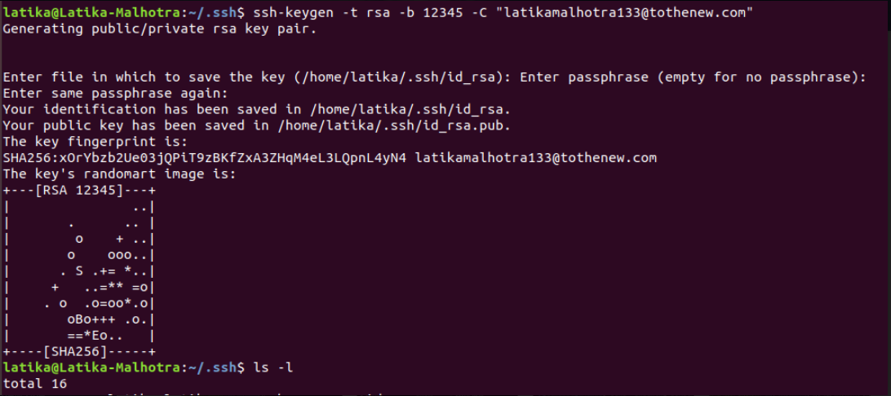



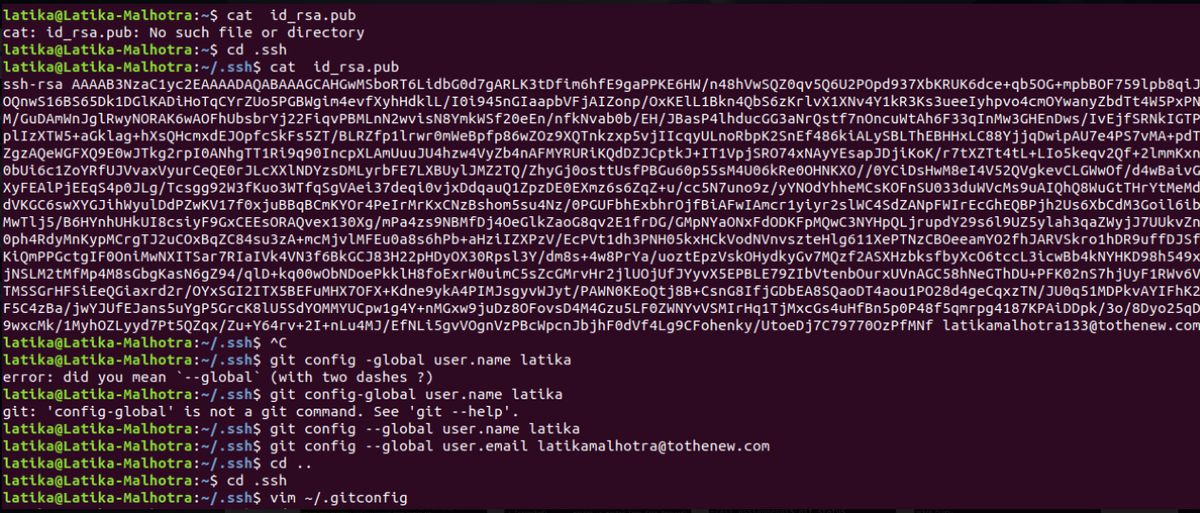

**QUES2-**Initialize a Git Repository

**Solution-**

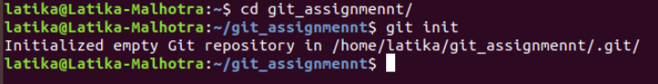

**QUES3-**Add files to the repository

**Solution-**

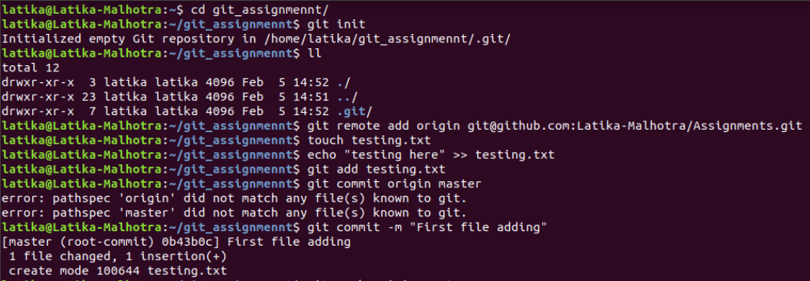

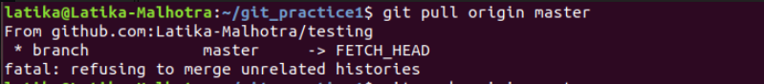



**QUES4-**Unstage 1 file

**Solution-**

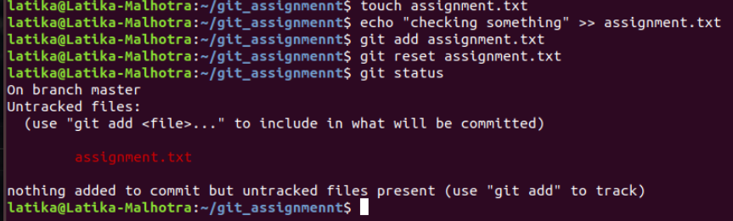

**QUES5-**Commit the file

**Solution-**

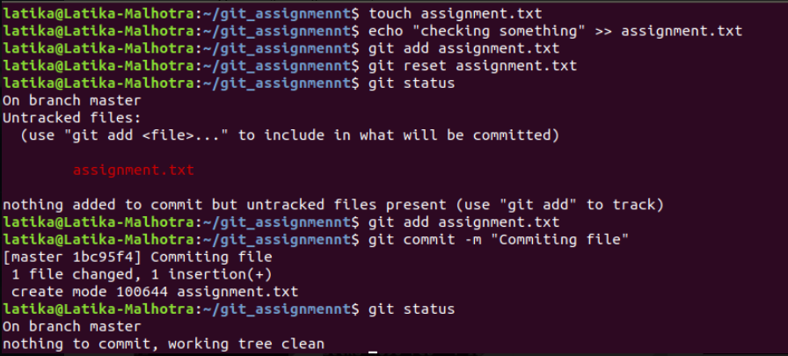

**QUES6-**Add a remote

**Solution-**



**QUES7-**Undo changes to a particular file

**Solution-**

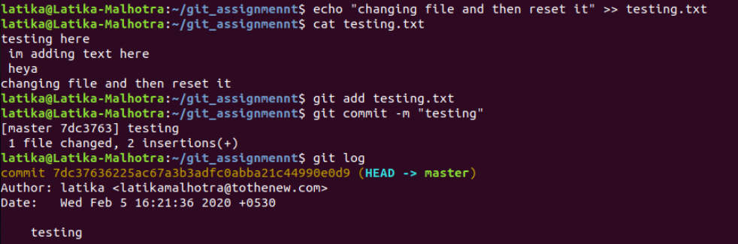

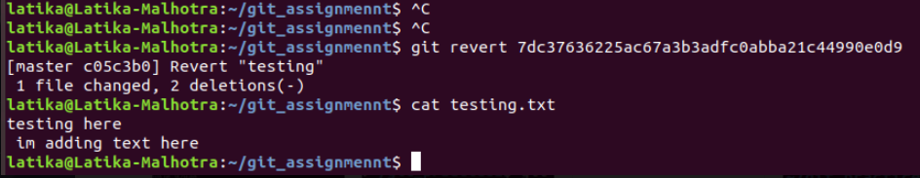

**QUES8-**Push changes to Github

**Solution-**

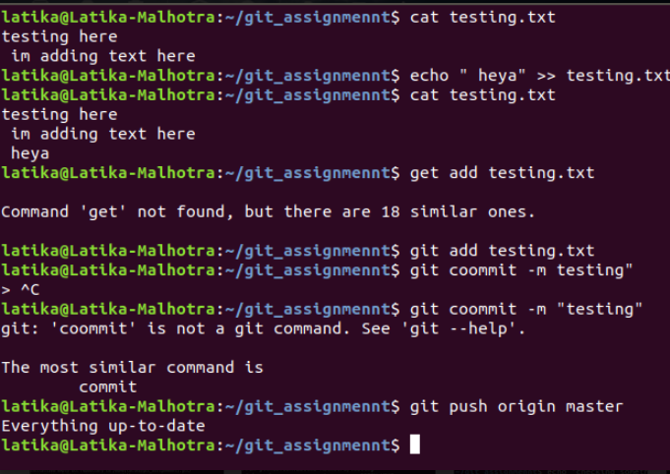

**QUES9-**Clone the repository

**Solution-**

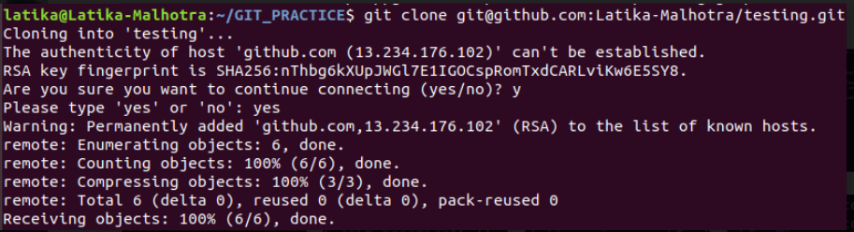

**QUES10-**Add changes to one of the copies and pull the changes in the other.

**Solution-**

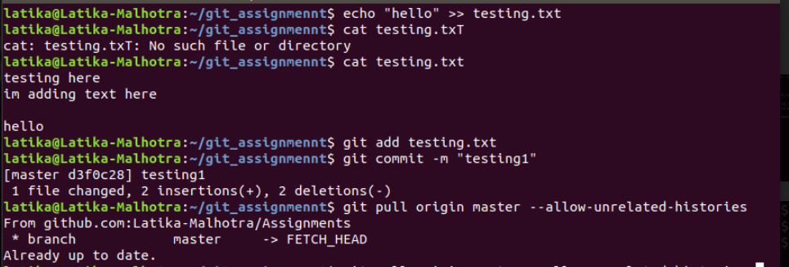

**QUES11-**Check differences between a file and its staged version

**Solution-**

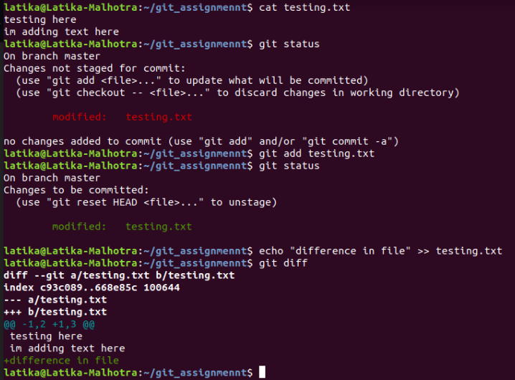

**QUES12-**Ignore a few files to be checked in

**Solution-**

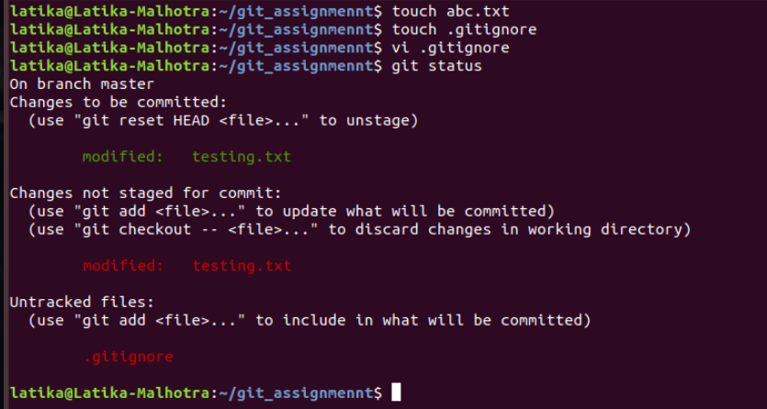

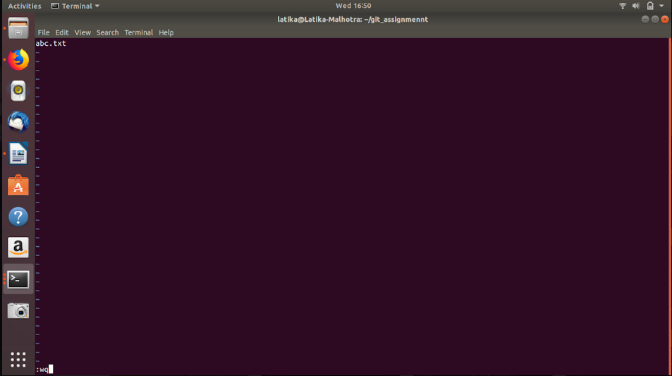

**QUES13-**Create a new branch.

**Solution-**

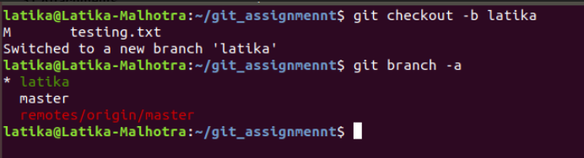

**QUES14-**Diverge them with commits

**Solution-**

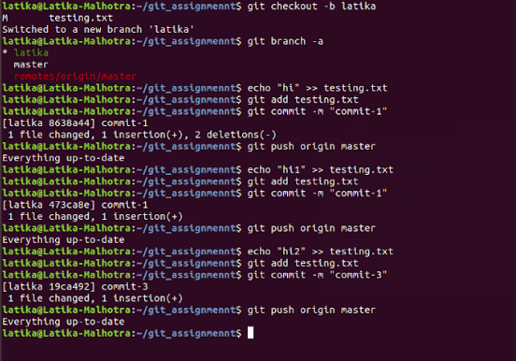

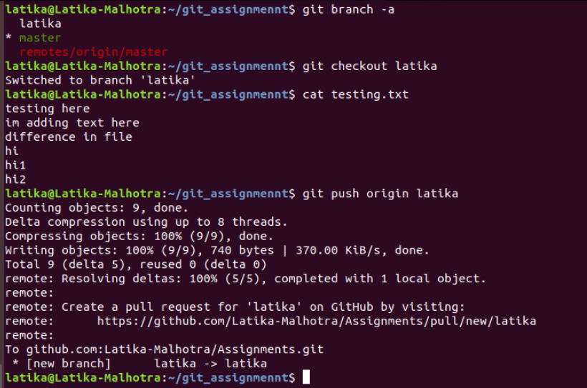

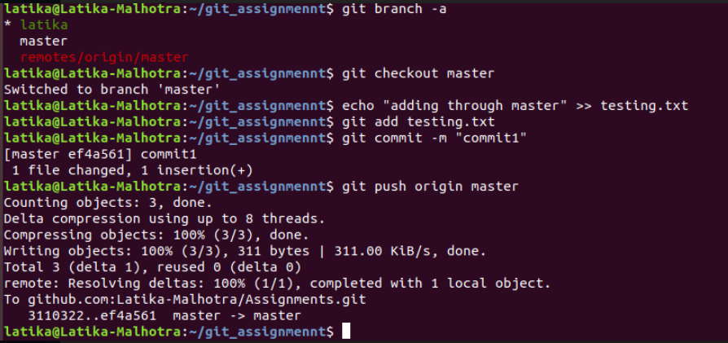

**QUES15-**Edit the same file at the same line on both branches and commit

**Solution-**

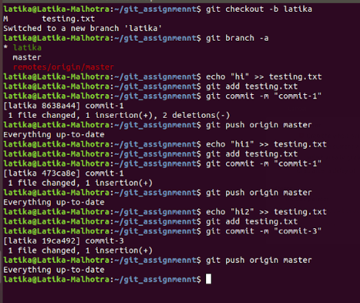





**QUES16-**Try merging and resolve merge conflicts

**Solution-**

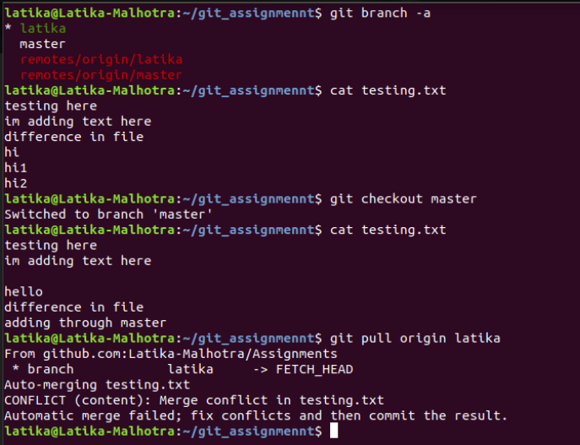

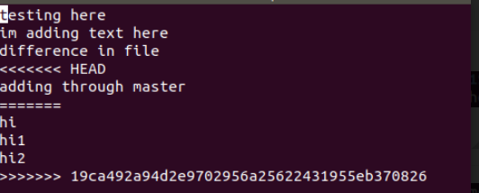

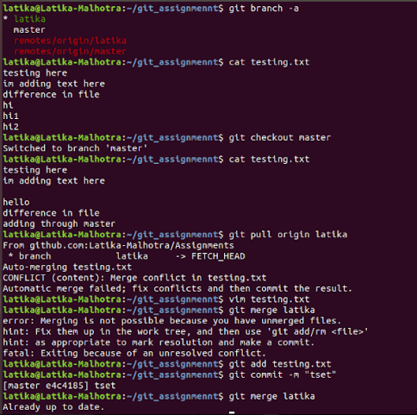

**QUES17-**Stash the changes and pop them

**Solution-**

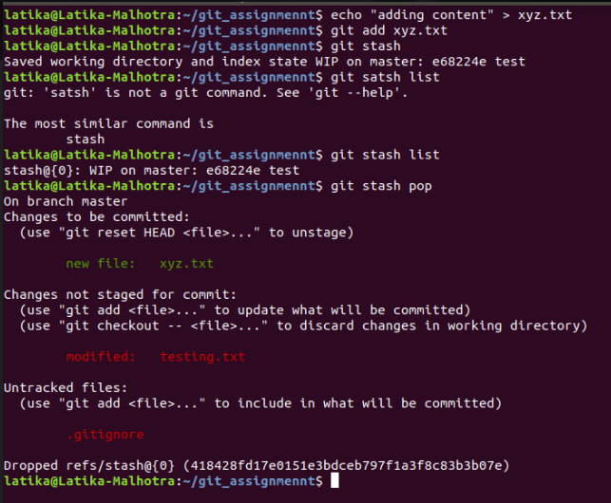

**QUES18-**Add the following code to your .bashrc file : color_prompt="yes"  
parse_git_branch() {  
git branch 2> /dev/null | sed -e '/^[^*]/d' -e 's/* \(.*\)/(\1)/'  
}  
if [ "$color_prompt" = yes ]; then  
PS1='\u@\h\[\033[00m\]:\[\033[  
else  
PS1='\u@\h:\W $(parse_git_branch)\$ '  
fi  
unset color_prompt force_color_prompt

**Solution-**

